**NIPWG response on IHMA Port Manual**

Paper for consideration by IHMA

Port Information Manual 1.4.5 review

|  |  |
| --- | --- |
| ***Submitted by:*** | NIPWG |
| ***Executive Summary:*** | Describes the finding and provides comments of the NIPWG on the IHMA Port Manual version 1.4.5 content related to NIPWG work |
| ***Related Documents:*** |  |
| ***Related Projects:*** | S-101, S-1xx (Marine Harbour Information) |

# Introduction/Background

The IHMA released the Edition 1.4.5 of their Port Information Manual in December 2019. NIPWG was invited to check the usefulness of the information provided in this Manual and an appropriate NIPWG letter has been issued. Many NIPWG members provided comments. The assessment of the responses has been summarised in the following four sections:

* Principal comments;
* Provision of information;
* Data Model comments; and
* Editorial comments.

# Analysis/Discussion

**Principal comments:**

When an S-100 based product specification “Marine Harbour Infrastructure” has been developed, it needs to be defined who will provide the product. Two principal scenarios are imaginable.

1. The provision of the product by the relevant harbour authority. That has the advantage that there is no new information supply chain needed between the harbour authorities and hydrographic offices (HO) to produce the product. The disadvantage is that all harbour authorities need to establish an S-100 based production environment and to build up the required technical expertise. That could be cost intensive and the global acceptance by all harbour authorities is doubtful.
2. The provision of the product by the relevant HO. The advantage is the existence of an appropriate production environment that can be adopted with very small efforts. Another advantage is that Nautical Publications issued by HOs are subject to SOLAS carriage requirements, and so they are on board. The HO staff is well trained to model the information. The big disadvantage is that the HOs will be highly dependent from the good will of the harbour authorities. Detailed and precise information is more demanding regarding its maintenance. Thus, the HO’s nautical products could provide this information only if the harbour authorities communicate this information regularly to the HOs.

A Memorandum of Understanding, which puts more reliability into the information exchange between harbour authorities and HO’s could be one way the resolve the dilemma described in the above paragraphs. Different Member States have no law that would force port authorities to submit changes that affect our publications though. HOs of theses Member States rely on the goodwill of the ports only and getting data from them is an issue.

Some NIPWG members reported that they never received requests from ports for the provision of information at the same level of detail as mentioned in the "Port Information Manual”. The main concern is based on experience that information flow from ports to hydrographic offices is, at present, often unsatisfactory. Ports may change and build facilities, but sometimes fail to inform the relevant HO. That means many HOs have removed harbour information from harbour ENCs because it was too challenging to keep the ENCs up to date.

**Provision of information:**

Nautical Publication information is primarily used for the voyage planning purposes. Nautical publication information complements the ENC information for route planning purpose. Route monitoring primarily uses ENC along with real-time data such as visual observations, ARPA, etc. The ENC gives precise location of objects. The Port Information Manual content should be assessed to determine what is needed for the berth-to-berth voyage planning and what is needed for route monitoring and which product specification would be the most convenient to store and to provide this information.

Generic information on terminals, berths and berth positions is useful for general voyage planning as well as planning vessel movements and activities within ports. When it comes to the specific creation of the route as part of the entire voyage, the necessary information should be available from the ENC. ENC should also contain all other pieces of information that should be available during route monitoring.

Thus, the description of the ports as specified in S-4, S-57 and S-101 should be reviewed to consider the needs expressed in the Port Information Manual. For example, berths are currently represented with a point symbol on paper charts (INT1 F19.1 - S4 § B-321.7 – see Fig.1). This implies that a large number of ENCs probably encode their BERTHS features with point geometry while linear objects are expected from the harbour master perspective.

The information on bollard number and meter mark number of berth position is useful to mariners. In order to capture this information the chart specifications may need revision. That in turn implies Nautical Cartography Working Group (NCWG), Electronic Navigational Chart Working Group (ENCWG) and S100WG (S-101 (Future ENC) Project team (PT)) are affected in addition to NIPWG.

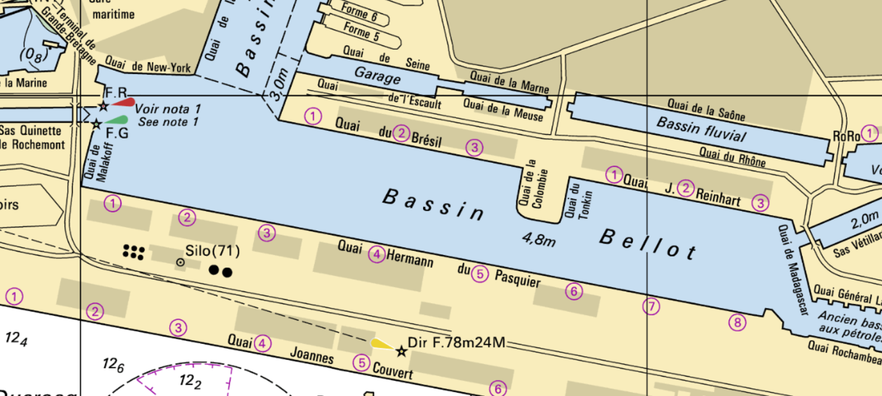

Fig 1 – Le Havre harbour on the French paper chart. Portrayal of berths using INT1 F19.1.

**Data Model comments:**

6.2 Definitions: The following definitions and data model concepts and components can be obtained from the NIPWG Wiki or the IHO HYDRO registry; preferably from the latter. We recommend that IHMA harmonize the Port Information model with the IHO and NIPWG definitions and approaches to these concepts:

* ISPS security level
* Maximum vessel sizes
* Time Zone
* Local holidays
* Working hours
* Cargo
* Point of contact
* Inter-ship communication
* Pre-arrival reports
* In port reports
* Pre-departure reports
* Regulations and exemptions
* Services

The meaning of the following definitions or sub-attributes is not clear:

* Charts

8.2 Horizontal restrictions: NIPWG will consider the creation of the following additional data model components from the IHMA model:

* Minimum Parallel Mid-Body alongside;
* Maximum Arrival Displacement;
* Maximum Displacement Alongside;
* LOCODE
* GLN (Global Location Number)
* Bollard location
* Berth number
* Meter marks.

11.8 Comparison of certain data elements used in the Port Information Manual (PIM) and the IHO Registry

|  |  |  |  |
| --- | --- | --- | --- |
|  | **PIM Items, location related** | **Identification & data fields** | **Related items in IHO GI Registry/FCD Register**  **(registry.iho.int) or NIPWG Wiki (<http://wp12183585.server-he.de/npubwiki/wiki/index.php/SNPWG>).** |
|  | General description | link berths to Terminal (and probably berth positions to berth; terminals to Port). | C_AGGR |
|  | Port | UN/LOCODE (P)  Name, general port data | HRBARE(HarbourAreaAdministrative):  S57&S101(A), covering only the water part (S58) |
| Areas & Lines Locations | Terminal | GLN (P, A)  Name, ISPS no., SMDG (cargo tracking) code, general terminal data | HRBFAC(HarbourFacility)/CATHAF(categoryOfHarbourFacility)=1,3,7,8,10,11…: S57&S101(P,A)  Terminal: Inland ENC |
|  | Berth | GLN (L, or actually P ?)  Need berth’s linear extent, with both ends named and/or numbered  Name, local reference, general berth data | BERTHS(Berth): S57&S101 (Point (P), Line (L), Area (A)) |
| Waypoints | Pilot boarding place |  | PILBOP(PilotBoardingPlace): S57&S101(P,A) |
|  | Berth position | GLN of Berth + extension (bollard/meter mark no…) |  |
|  | Fairway | GLN, name | FAIRWY(Fairway): S57&S101(A) |
| Sections | Turning basin | GLN, name, max. length | RESARE(RestrictedArea)/CATREA(categoryOfRestrictedArea)=25(swingingArea): S57&S101(A)  TurningBasin: Inland ENC |
|  | Basin | GLN, name | HarbourBasin: Inland ENC |
|  | Berth pocket | GLN, name | BERTHS(Berth): S57&S101(P, L, A) |
| Berth | Bollard | number | MORFAC(MooringWarpingFacility)/CATMOR(categoryOfMooringWarpingFacility )=3(bollard): S57&S101(P,L,A) |
| Port | Nautical services | Type, name, service area, details, working hours  (PIM p.32) | IHO registry: Service hours (ServiceHours) information type) schedule by day of week (scheduleByDayOfWeek) complex attribute; |
| Port | Vessel services | Type, name, service area, details, working hours  (PIM p.32) | (see previous row for service hours, working schedule, etc.)  NIPWG Wiki: Supplies (SUPPLY) feature type; category of supply (CATSUP) attribute; repair service (SRVREP) attribute; technical port service (SRVTEC) attribute; category of supply (CATSUP); |
| Port | Emergency response equipment | Types, availability  (PIM p.31) |  |

Further:

Consider the S-211 (Port Call Message Format) data model elements introduced by the International PortCDM Council (IPCDMC) and fully registered in the IALA domain of the IHO GI register.

**Editorial comments:**

All: Replace “harbor” by” harbour” for consistency unless it is truly spelled “harbor” from the source. (NP100)

All: Spell out the abbreviations when mentioned the first time, add a list of abbreviations

2.2 First Sentence. Add a period after “chain”

2.5 First Sentence. Add a period after “Guide”

2.6 Local community or state and National or federal authority: Replace “… efficient shipping. Certainly if the income …” by “… efficient shipping, especially if …”

2.6 National or federal authority, last sentence. Add a period after “difficult”

2.6 A mix of local / state community and national / federal authority. . Add a period after “before”

2.6 Private parties. Replace “… instances normally…” by “… “… instances are normally …”

2.6 Second it depends on whether nautical and vessel services are private or public. Add a close quote after “Internal Operator.

5.2 Definition. Terming Basin. Add a period after “purpose”

6.2 Delete duplication paragraphs “General Information”, “Developments” and “Limits description”

10.6 Container sector, second bullet point. Delete the “6+”

11.1 Delete the space after “BIMCO”

11.1 Replace “,” by “and” between GS and Informational

11.3 Second paragraph. Delete the second “)” after GLN

12.1 Replace “not-for-profit” by “non-profit”

# Impacts

The provision of port information in a harmonised way provides fast and structured access to port information globally. It is one step towards the common goal of a digitised, more efficient and environmental friendly maritime transport.

A close cooperation between the harbour authorities and the HOs is requested. The HOs workload will increase. The responsibility of all harbour authorities on their data increases.

# Actions Requested

It is recommended that the IHMA

* Review the Port Information Manual considering the technical and editorial comments.
* Discuss and develop a sufficient way within the harbour master community to provide and update port information globally in a reliable, sustainable and accurate way.
* Inform IHO on the discussion results,
* Develop alternative approaches if no global agreements can be achieved.

It is recommended that the NIPWG

* Seek HSSC endorsement to initiate the development of an S-100 compliant product specification “Marine Harbour Information”.
* Inform HSSC that other WGs should also be involved in modelling Port Information Manual data (S101PT, ENCWG, NCWG).
* Establish close liaison with the International PortCDM Council (IPCDMC) when starting the development.